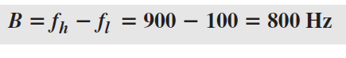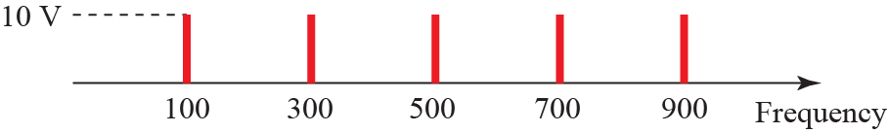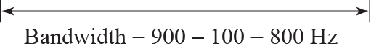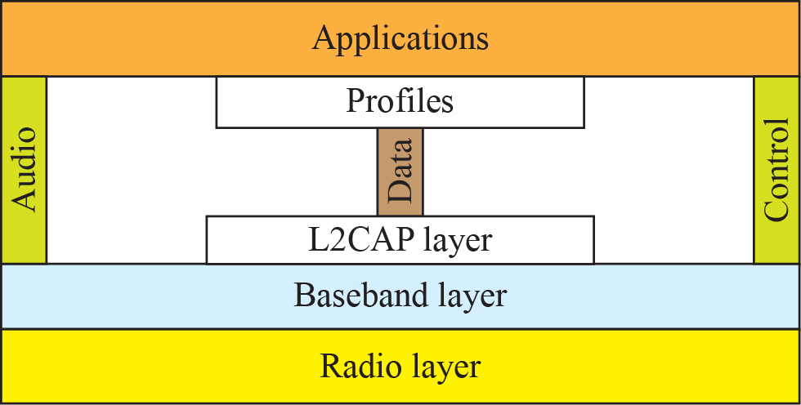

**Midterm Examination preparation**

**Part I : MCQ**

1 Which topology requires a multipoint connection?

1. Mesh
2. Star
3. **Bus**
4. Ring

2. In TCP/IP the _______ layer is equivalent to the combined session, presentation, and application layers of the OSI model.

* 1. **Application**
  2. Network
  3. Data link
  4. Physical

3. The physical layer is concerned with the movement of _______ over the physical medium.

* 1. programs
  2. dialogs
  3. protocols
  4. **bits**

4. _______ is a process-to-process protocol that adds only port addresses, checksum error control, and length information to the data from the upper layer.

* 1. TCP
  2. **UDP**
  3. IP
  4. MAC

5. Which of the following is one of the components of a data communication system

* 1. Message
  2. Sender
  3. Medium
  4. **All of the above choices are correct**

6. In the TCP/IP protocol suite, which of the following is not an application layer protocol?

* 1. HTTP
  2. FTP
  3. **IP**
  4. Telnet

1. The data link layer packet in the TCP/IP protocol suite is called
   1. A message
   2. **A Frame**
   3. A segment or user datagram
   4. A datagram
2. The Internet Protocol (IP) is _______ protocol
   1. A reliable
   2. A connection oriented
   3. A reliable and connection oriented
   4. **An unreliable**
3. __________ can impair a signal
4. Attenuation
5. Distortion
6. Noise
7. **All of the above choices are correct**

10 BNC is a type of connector used in ………. Cabling

1. Twisted-pair
2. **Coaxial**
3. Fiber-optic
4. None of the choices are correct

11 Twisted in a twisted-pair help reduce the ……….

1. Length
2. Cost
3. **Noise**
4. None of the choices are correct

12. . RJ-45 is a type of connectors used in ____________cabling.

**a) twisted-pair**

b) coaxial

c) fiber-optic

d) None of the choices are correct

13 . Transmission media are usually categorized as ………..

* 1. Fixed or unfixed
  2. **Guided or unguided**
  3. Determinate or indeterminate
  4. Metallic or nonmetallic

14. Which protocol is used to resolve IP to MAC addresses?

* 1. DNS
  2. DHCP
  3. **ARP**
  4. WEP

15. Media Access Control can be presented only in a _______________link(s)

* 1. point-to-point
  2. **multicast**
  3. both point-to-point and multicast
  4. Non of the choices are correct

16 Communication at the data-link layer is

a) end to end

**b) node to node**

c) process to process

d) None of the choices are correct.

17. In the ________ random- access method collision is avoided.

a) CSMA/CD

b) ALOHA

**c) CSMA/CA**

d) None of the choices are correct.

* + 1. Standard Ethernet data rate

1. **10Mbps**
2. 100Mbps
3. 1Gbps
4. 10Gbps
   * 1. 10 Gigabit Ethernet operates only in
5. Simplex mode
6. Half duplex mode
7. **Full duplex**
8. none
   * 1. In 10Base2 implementation the medium length

a) 500m

**b) 185m**

c) 100m

d) none

**PART II Fill in the Blanks**

1. The largest geographic area in a WAN can span is____________

**The world**

1. In a star topology with five computers, we need ____________ links

**Five**

1. The data sent in the network layer in TCP/IP model is called ____________  **Datagram (Packet)**
2. In BUS topology, at each end of the bus is a ____________, which absorbs any signal, removing it from the bus. **(terminator)**
3. The _________ layer enables the users to access the network. **(application)**
4. ____________data have discrete states and take discrete values**. (Digital)**
5. Transmission media lie below the __________ Layer**. (physical)**
6. The IEEE 802.11 FHSS uses ___________modulation. **( FSK)**
7. BLUETOOTH is a_________ Technology that connects devices in a small area. **(wireless LAN)**
8. Data- link layer of a point- to point link has _____sublayers. **(one)**

**Part III TRUE and FALSE**

|  |  |  |
| --- | --- | --- |
| 1 | In TCP/IP, a message at the transport layer is encapsulated in a packet at the data link layer. | **False** |
| 2 | In the TCP/IP protocol suite, a port number is the identifier at the transport layer. | **True** |
| 3 | Currently IEEE is responsible for the management of Internet Domain Names & Addresses | **False** |
| 4 | A WAN interconnects hosts; a LAN interconnects connecting devices such as switches, routers, or modems. | **False** |
| 5 | A multipoint connection is one in which more than two specific devices share a single link | **True** |
| 6 | In CDMA, we use different codes to achieve channelization. | **True** |
| 7 | In the CSMA/CA random access method collision is not avoided. | **False** |
| 8 | In FDMA, we use different time slots to achieve channelization. | **False** |
| 9 | RG rating is used in coaxial cable. | **True** |
| 10 | CSMA/CD stands for carrier sense multiple access collision detection. | **True** |

**PART IV Short Questions.**

If a periodic signal is decomposed into five sine waves with frequencies of 100, 300, 500, 700, and 900 Hz, what is its bandwidth? Draw the spectrum, assuming all components have a maximum amplitude of 10 V.

**Solution**

Let fh be the highest frequency, fl the lowest frequency, and B the bandwidth. Then







1. **Name the four basic network topologies, and cite an advantage of each type.**

Solution

We give an advantage for each of four network topologies:

a. Mesh: secure

b. Bus: easy installation

c. Star: robust

d. Ring: easy fault isolation

3. . Distinguish between a point-to-point link and a broadcast link.

Ans

A point-to-point link is dedicated to the two devices connecting at the two ends of the link. A broadcast link shares its capacity between pairs of devices that need to use the link.

* + 1. Draw the figure which shows several layers of Bluetooth?

Solution



5. What is the difference between the bandwidth and the throughput?

Answer :

The term bandwidth can be used in two different contexts with two different measuring values: bandwidth in hertz and bandwidth in bits per second. The throughput is a measure of how fast we can actually send data through a network. Although, at first glance, bandwidth in bits per second and throughput seem the same, they are different. A link may have a bandwidth of B bps, but we can only send T bps through this link with T always less than B.